Generic email Flow, with OR, not with AND

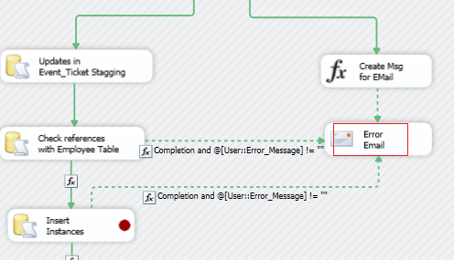

Add an email control

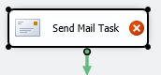

CONFIGURE SERVIDOR CORREO

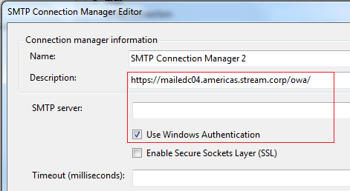

Description: mailedc01 this one works

LA DIRECCION EN OUTLOOK

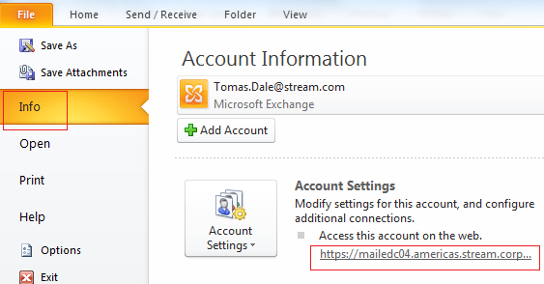

In the SSIS menu

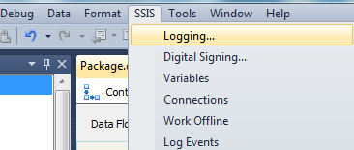

On the Configure SSIS Logs: dialog, select the provider type and click Add. Check the Name checkbox and provide the data source under **Configuration** column. Here **SQLServer** is the name of the connection manager.

SSIS will create a table named **dbo.sysssislog** and stored procedure **dbo.sp_ssis_addlogentry** in the database that you selected.

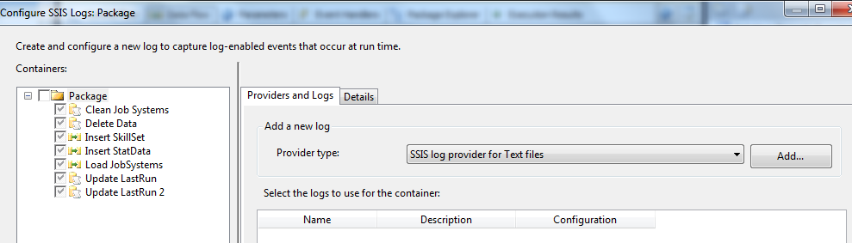

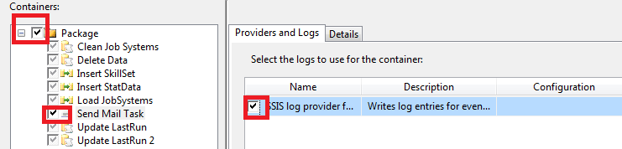

Now go to Details

If you need to capture the errors, select the checkbox OnError and OnTaskFailed.

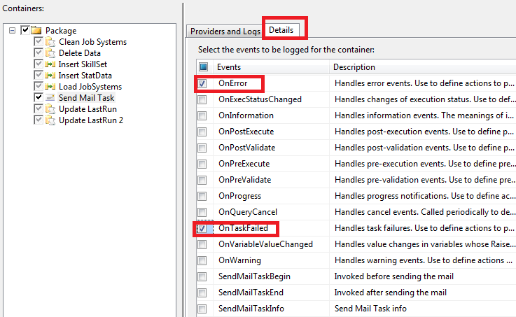

Sample output of the log table **dbo.sysssislog**

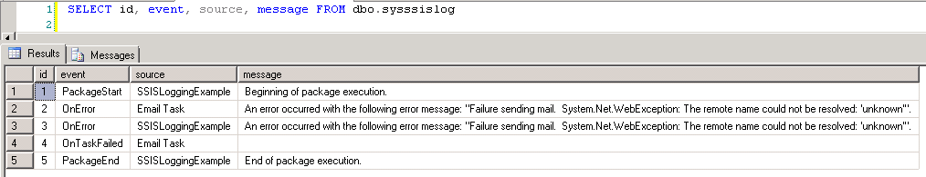

|  |
| --- |
|  |

I have only displayed few columns id, event, source and message. There are other columns in the table. Message column contains the error message, here in this case the server name mentioned in the Send Mail Task is wrong. Source column contains the task where it failed. Here in this case, the package name is **SSISLoggingExample** and Send Mail Task is named as **Email Task**. Error messages will bubble up from task to the package level. Hence, the error message is logged twice under the task as well as at the package level.

Public Sub Main()

Dim vErrorDescription As String = Dts.Variables(“ErrorDescription”).Value.ToString

‘declare a variable for package name  
Dim vPackageName As String = Dts.Variables(“PackageName”).Value.ToString

‘Write error string to DTS variable  
Me.Dts.Variables(“vFullErrorMsg”).Value =  
“ERROR: ” & ” Package [" & vPackageName & "] Failed” & “. Full Description: ” & vErrorDescription

‘ write DTS variable to a file using stream writer  
Using sw As StreamWriter = New StreamWriter(“D:\Documents\ErrorLog.Txt”, True)  
 sw.WriteLine(Dts.Variables(“vFullErrorMsg”).Value.ToString)

End Using

Dts.TaskResult = ScriptResults.Success

End Sub

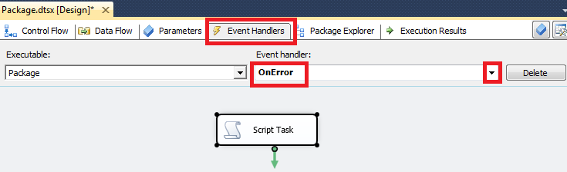

Edit Script Task and select System::ErrorDescription variable

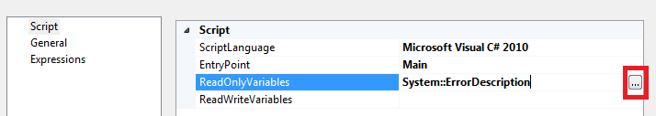

Click at the Bottom “Edit Script”

Dim messages As Collections.ArrayList   
Try  
messages = CType(Dts.Variables(“errorMessages”).Value, Collections.ArrayList)  
Catch ex As Exception  
messages = New Collections.ArrayList()  
End Try   
messages.Add(Dts.Variables(“ErrorDescription”).Value.ToString())   
Dts.Variables(“errorMessages”).Value = messages   
Dts.TaskResult = Dts.Results.Success

public void Main()

{

// TODO: Add your code here

ArrayList messages;

try

{

messages = (ArrayList)(Dts.Variables["errorMessages"].Value);

}

catch (Exception ex)

{

messages = new ArrayList();

}

Dts.TaskResult = (int)ScriptResults.Success;

}

For Each errorDesc In messages  
Dts.Variables(“emailText”).Value = Dts.Variables(“emailText”).Value.ToString + errorDesc + vbCrLf  
Next

GENERIC

